**Hướng dẫn sử dụng**

# How work is organized

1. [Goals](https://help.asana.com/hc/en-us/articles/14111312236827): Goals are high-level objectives that represent the overarching priorities for an organization or team. They are set within Asana Goals and provide a clear direction for the work being done.
2. [Portfolios](https://asana.com/guide/team/onboard/portfolio-management): Portfolios are containers that group related projects together. They help track progress toward specific initiatives or objectives.
3. [Projects](https://asana.com/guide/get-started/begin/create-project): Projects organize and manage work related to a specific initiative. Projects house tasks and subtasks, allowing for dividing work into manageable units and facilitating collaboration.
4. [Tasks](https://asana.com/guide/help/tasks/understanding-tasks): Tasks represent the individual action items within a project. They have due dates and can be assigned to specific team members.
5. A diagram of a diagram

   Description automatically generated[Subtask](https://help.asana.com/hc/en-us/articles/14101387791899): Subtasks are smaller units of work within a task, often used for breaking down more complex tasks into manageable steps.

# How people are organized

1. [Organizations](https://asana.com/guide/help/organizations/basics) are based on your company’s shared email domain and connect everybody within your company that uses Asana.
2. [Teams](https://asana.com/guide/help/organizations/team-basics) are functional groups in an organization that likely correspond to departments, like Marketing or Sales, or functional groups like "NYC Office."
3. [Members](https://help.asana.com/hc/en-us/articles/14106290641691-Managing-an-organization#gl-people): Members are users who have full access to the workspace or organization and its features.
4. 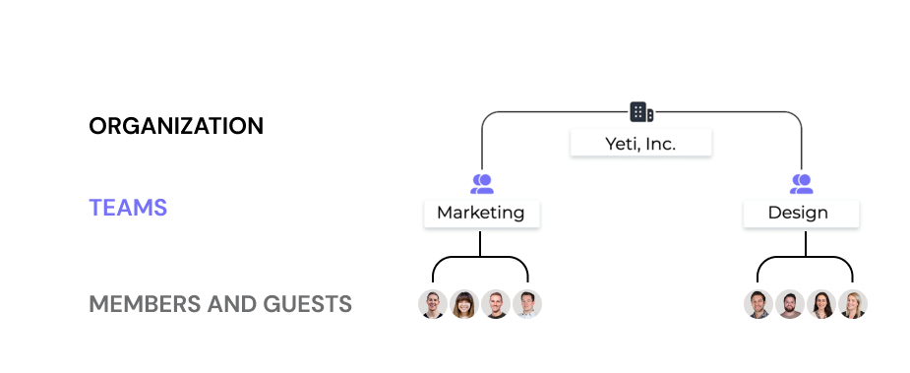[Guests](https://help.asana.com/hc/en-us/articles/14106290641691-Managing-an-organization#gl-people): Guests have more limited access and are often invited to collaborate on specific projects or tasks.